Code:

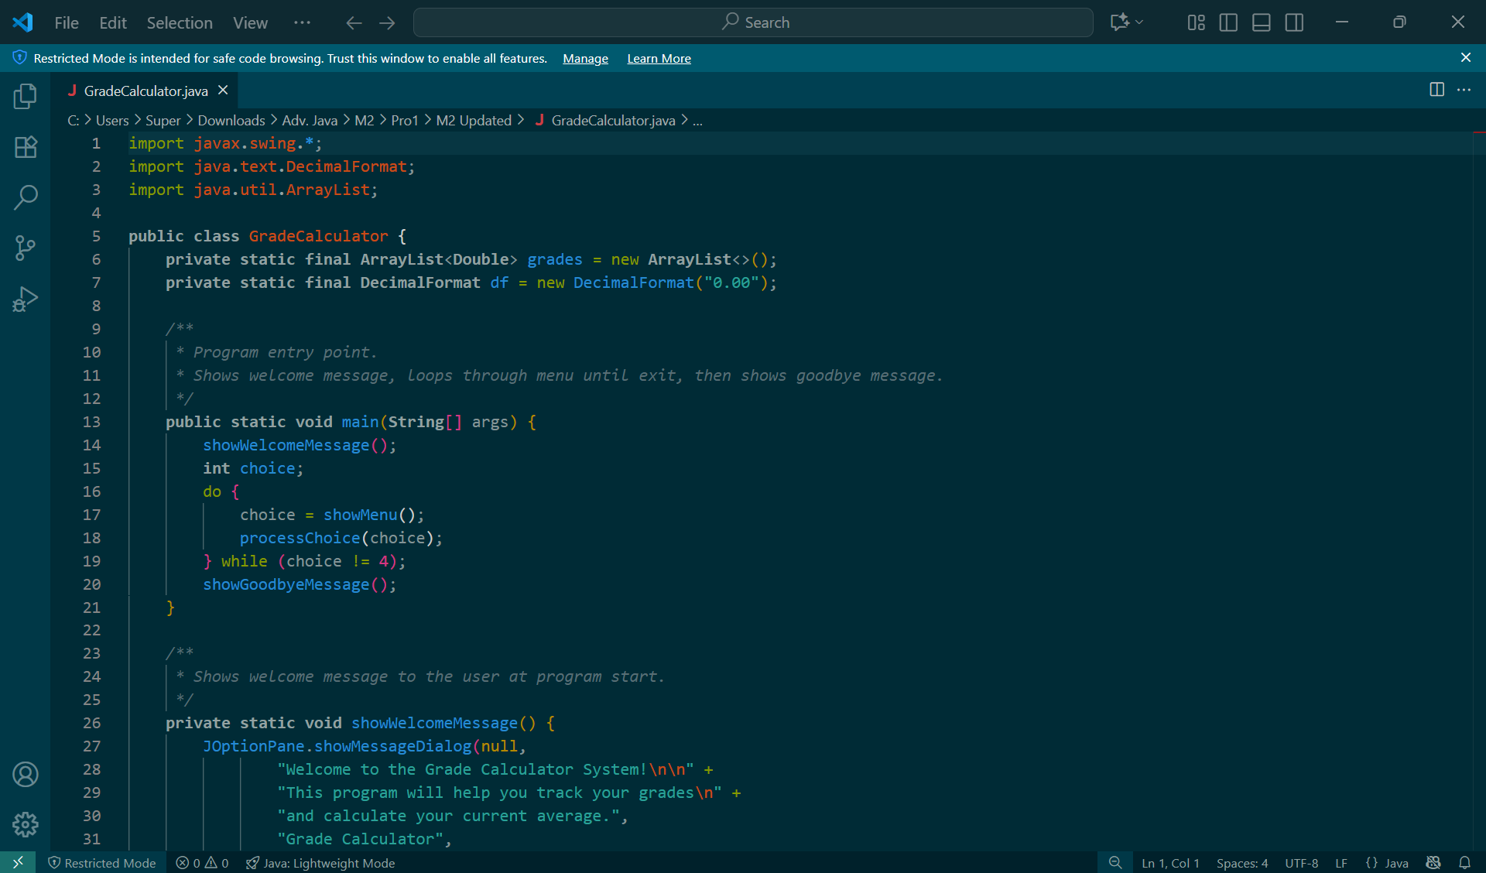

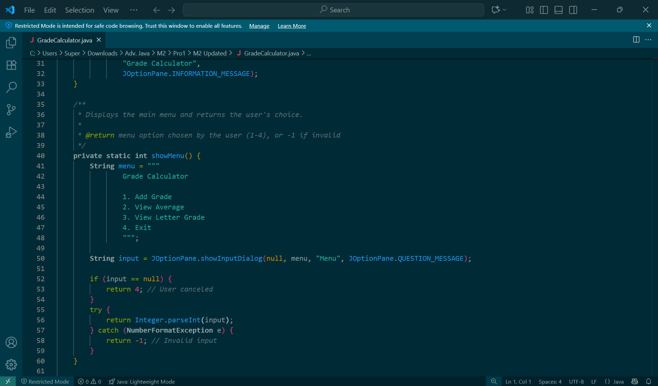

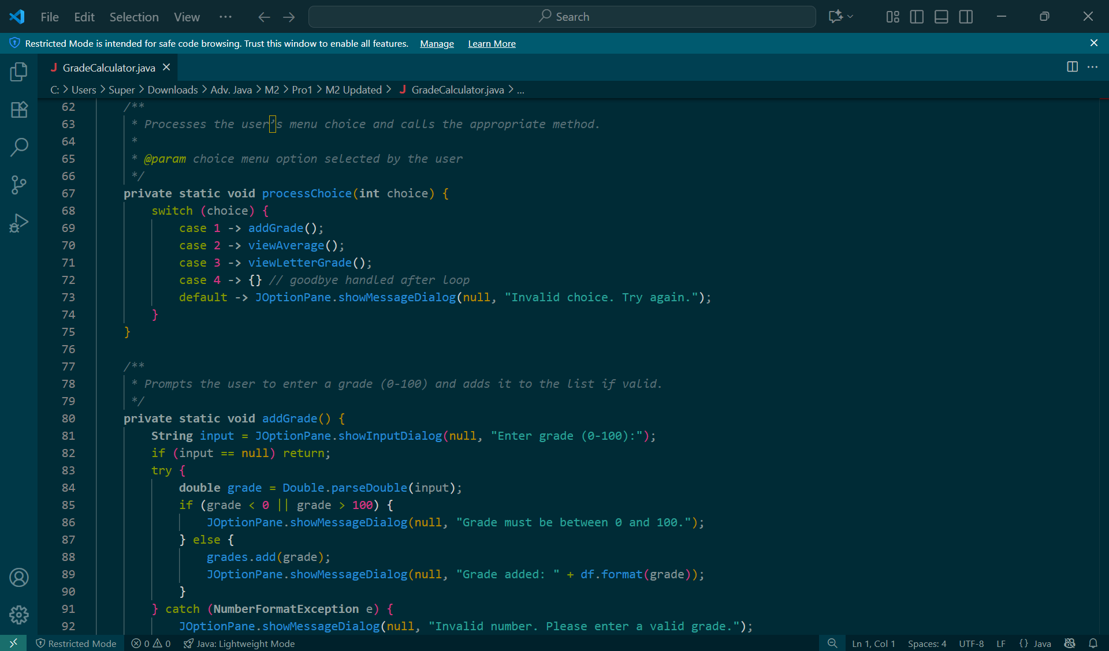

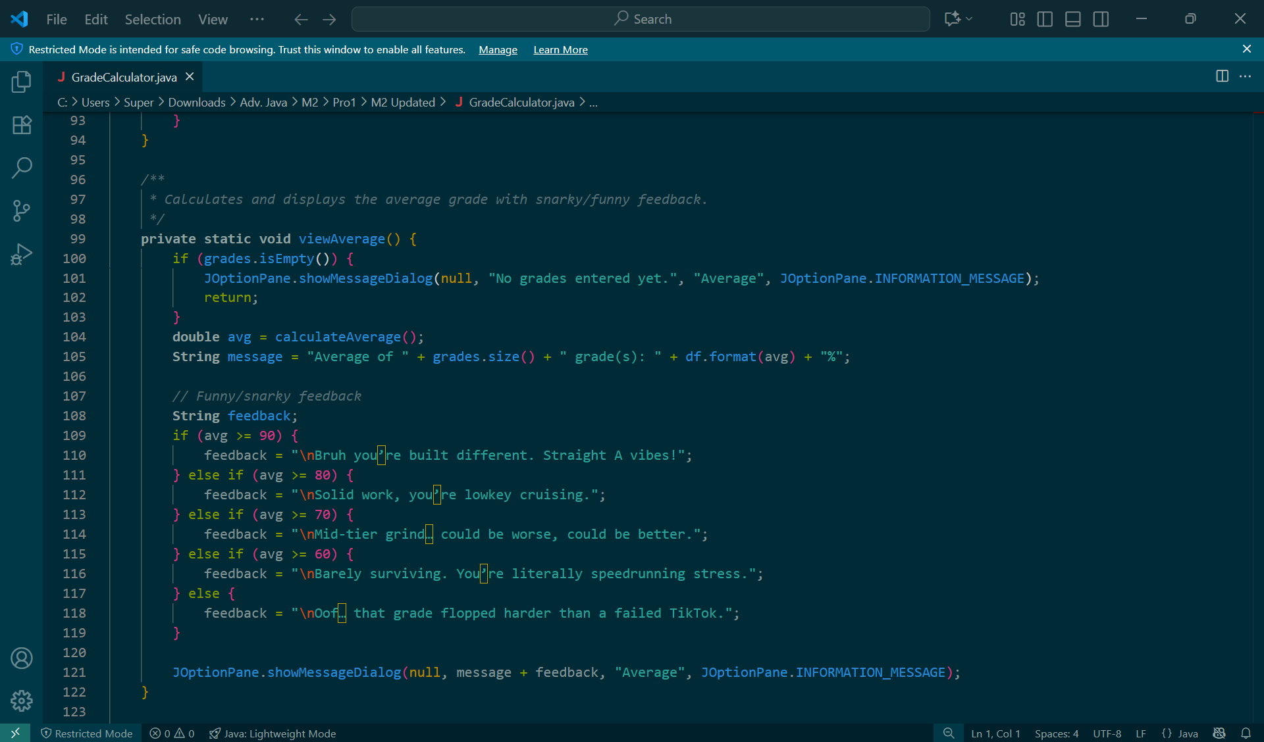

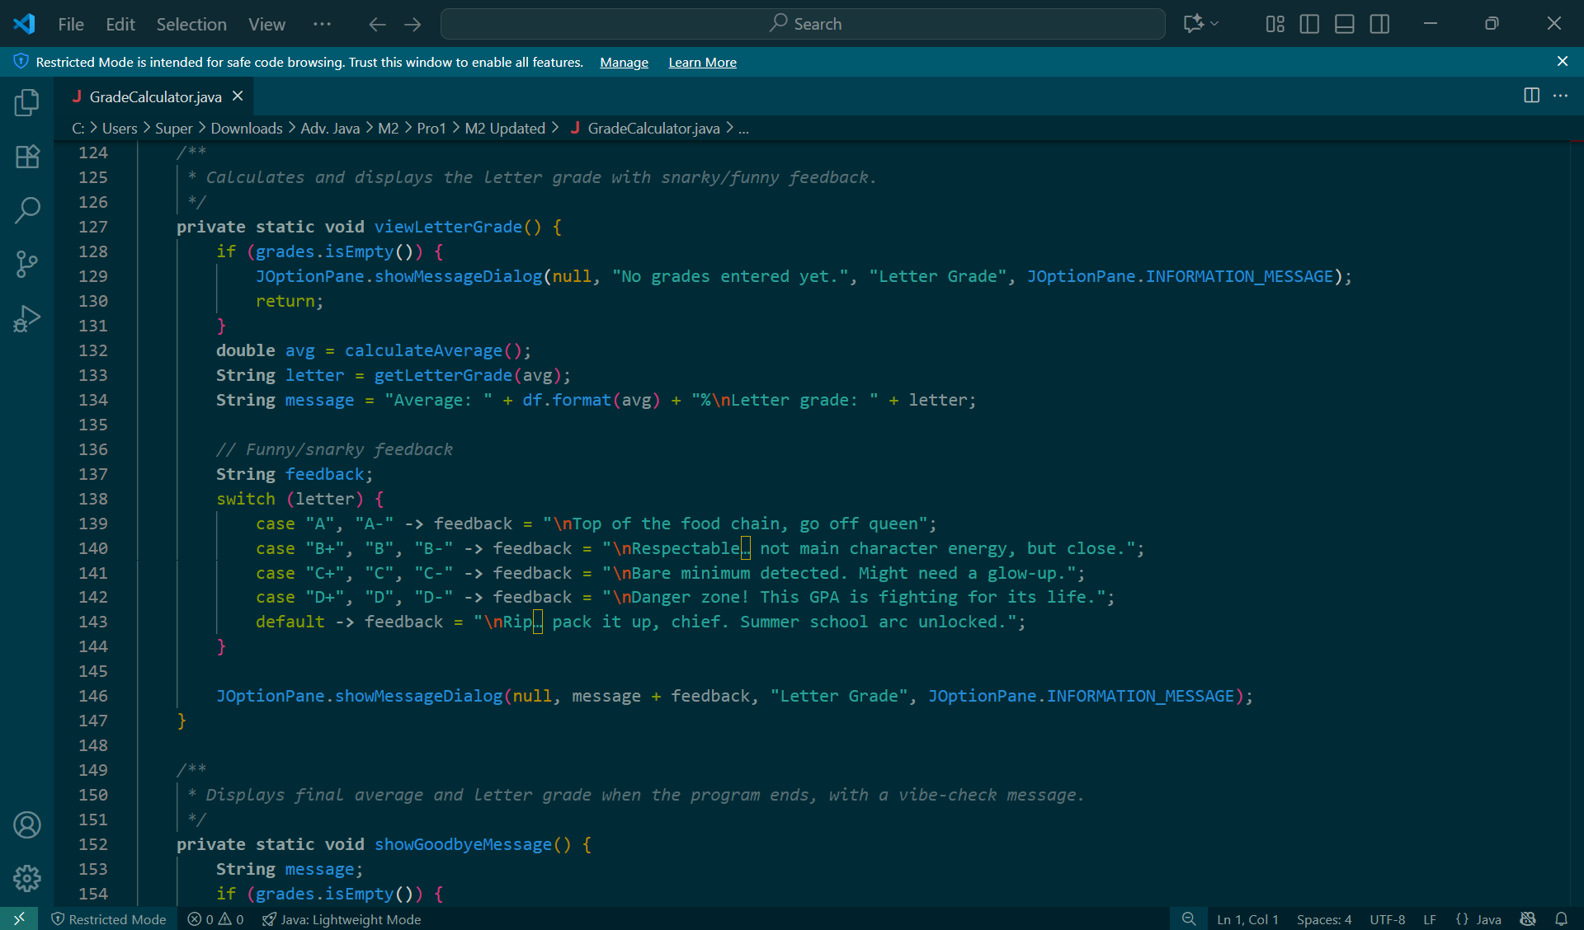

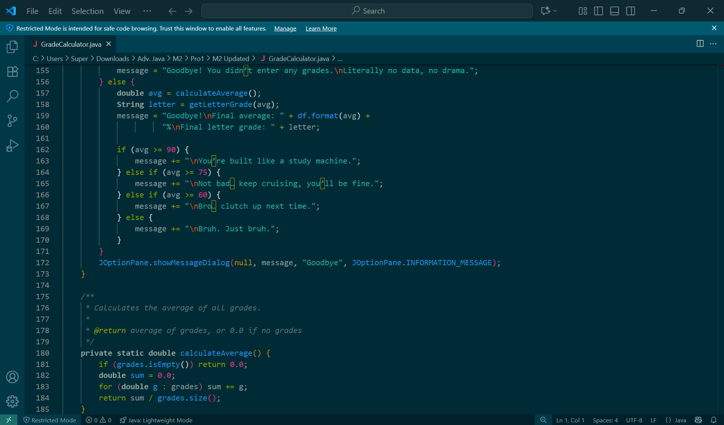

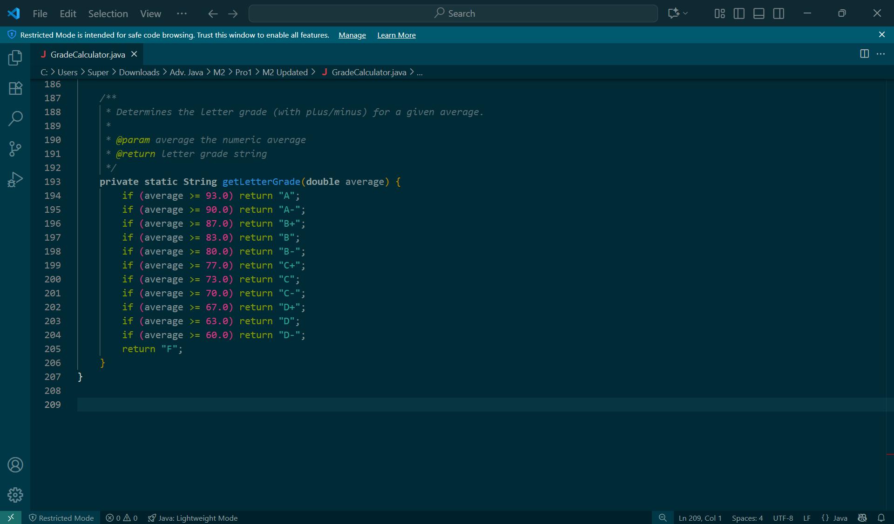

Output:

